Lab - Week 6: REST APIs

**Exercise 1 - Install 5.0 .NET Core SDK**

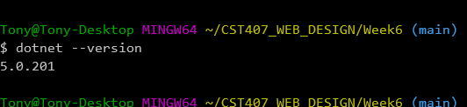

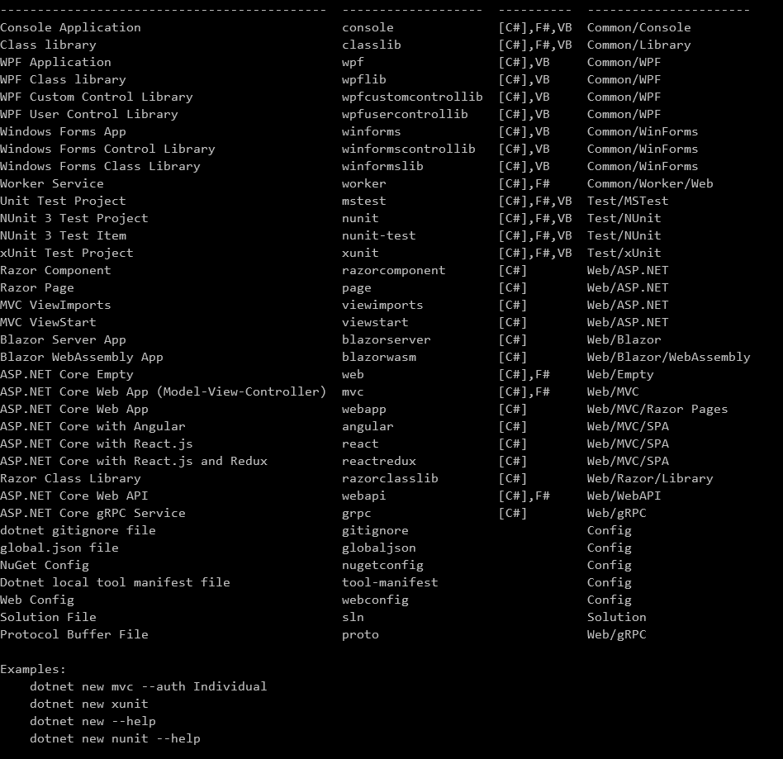

**Exercise 2 - Create the sample .NET Core WebApi (REST Service)**

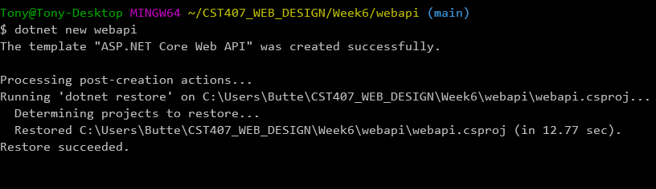

**Exercise 3 - Run the sample WebAPI/REST**

**Include a screenshot of Postman showing the request URL and the resulting output with HTTP response codeService**

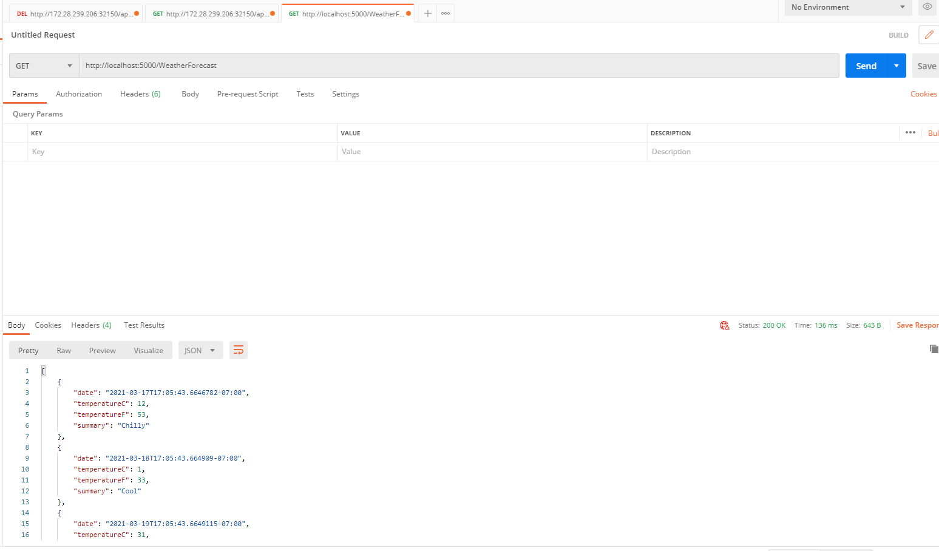

**Include a screenshot of Postman showing the request URL and the resulting output with HTTP response**

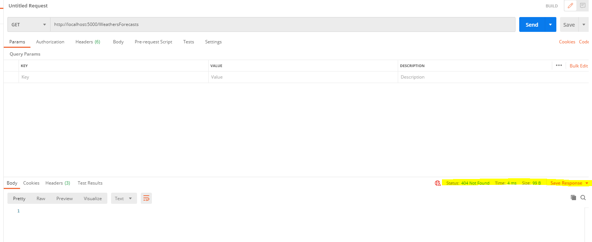

**Exercise 4 - Create the controllers for your API/REST service**

**Include a screenshot of both the student and instructor JSON output shown in Postman**

**(Student)**

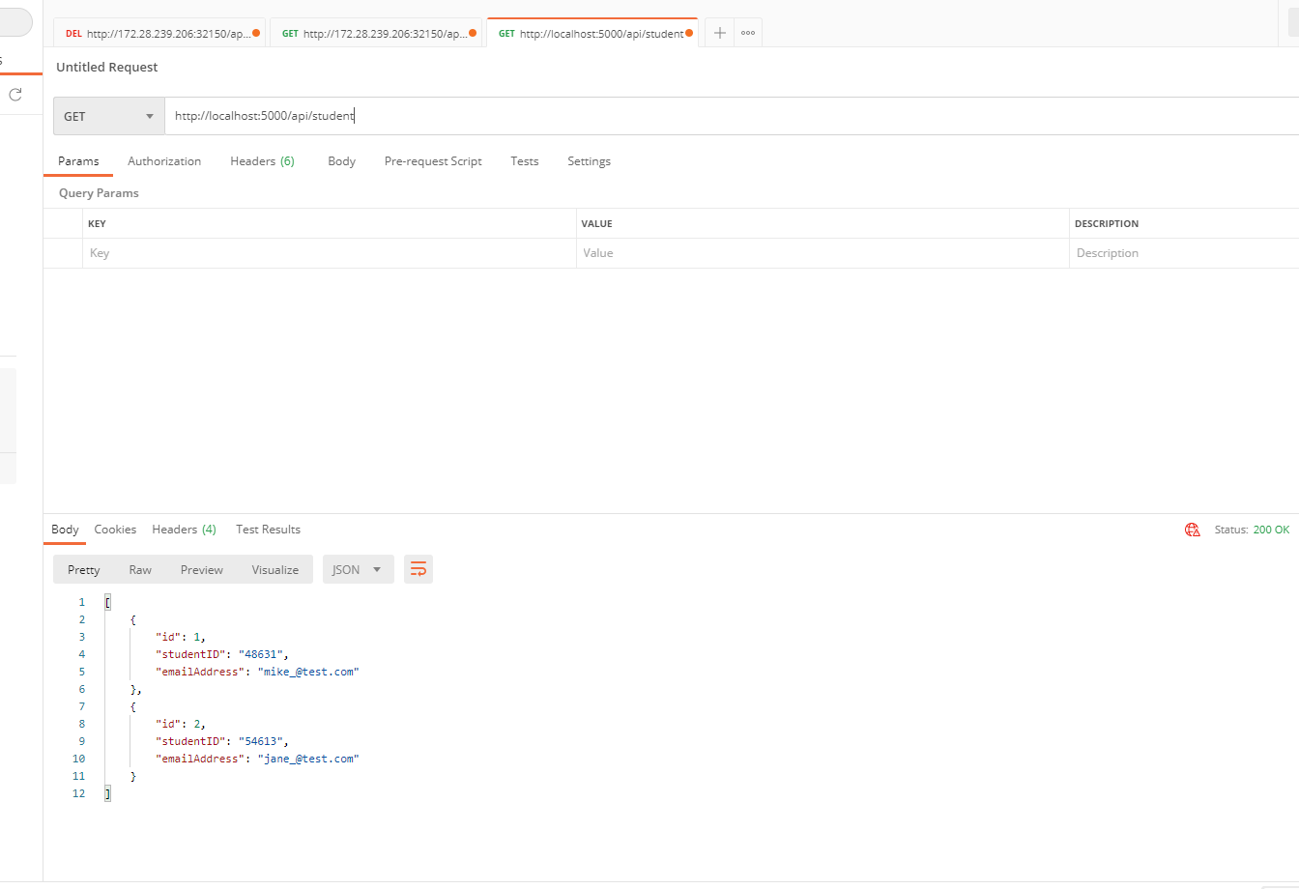

**(Instrutors)**

